How to add a new page:
- Navigate to ITube/New and create a new html document. Make sure it’s completely blank.
- Open the new page template. Copy its contents into your new file.
- Find the spots where it says <!--REPLACE THIS--> and change the information
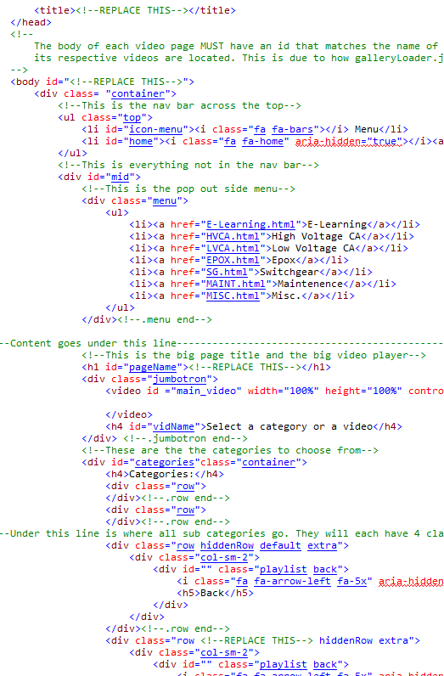
Change these!

- Change the fields I marked above to the following:
  - The <title> is the name of the page and will appear in the tab in the browser. This should be the name of your category.
  - The <body> id is very important. This should be a name that is a good fit for the page. Remember this name as it will be used later to locate playlists.
  - The h1 #pageName is the title the goes across the top of the page above the video player. Make this the title of the page.

- Time to create the folder where the playlists associated with this page will be.
  - Navigate to ITube/New/playlists and create a folder named that has the same as the id from earlier.
  - This folder is where the video thumbnails your categories load are located
- Create your category buttons and the html documents they will use. If you don’t know how to do this read the other instructions I left.
  - Make sure you create a rootVideos.html in this new folder. Look at the other ones to get a sense of what the markup should look like.
- Now that there is a new page, you need to add it to the slide menu on each of the other pages. Look for div.menu and inside the ul add another <li><a> that has a href that points to your new page. You need to do this for every other page or else you won’t see it in the menu!
- Remember to save and your new page should be available on the I-Tube

